First, run the server, then, run the client, and input the id and operation and value after it tells the user to enter. If the user wants to quit, then input “quit” when it tells the user to input, and both the client and server side will quit.

This is the client:

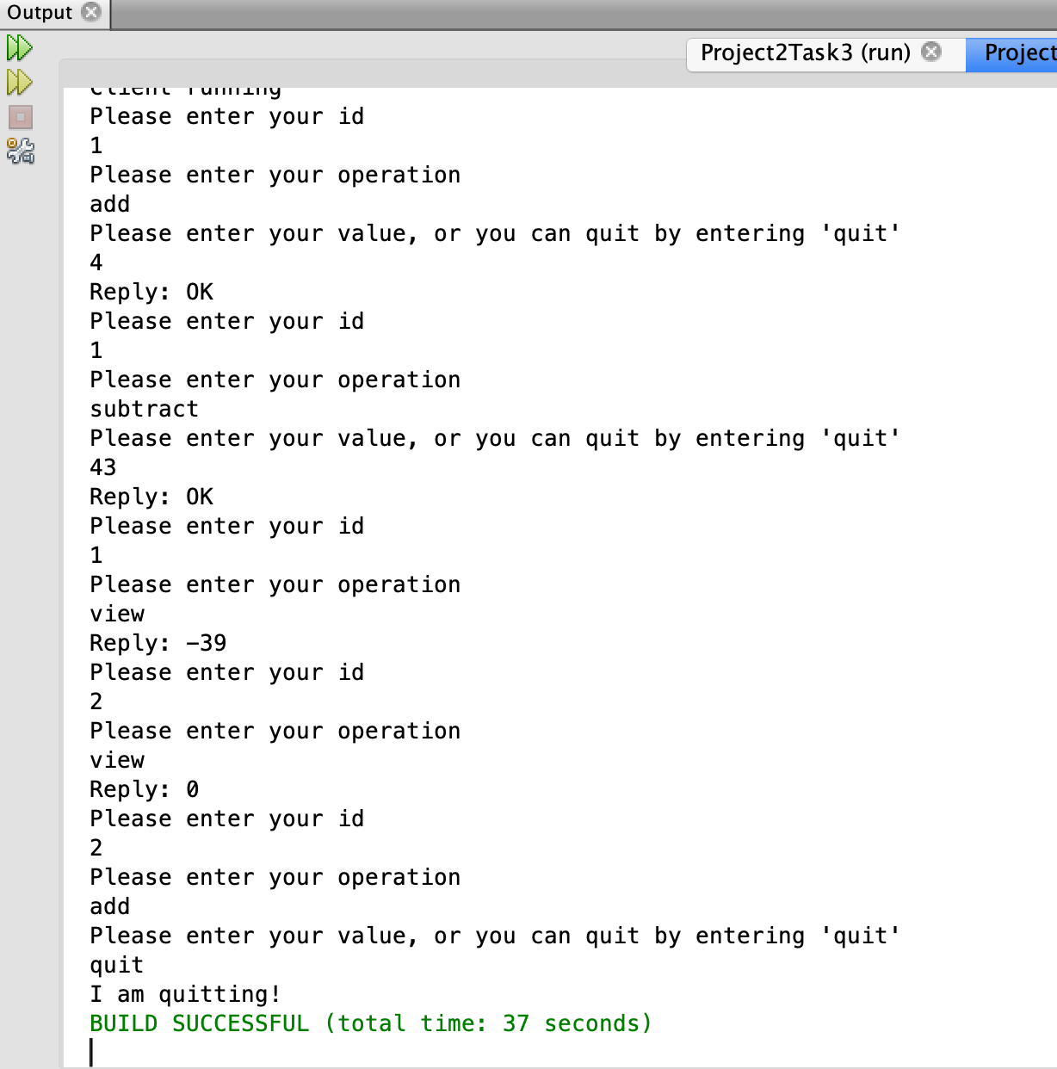

This is the server:

